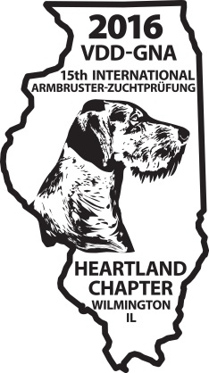2016 Armbruster Meal Registration form
Please RSVP by September 16, 2016
Wednesday October 5, 2016
BBQ Country Buffet: Potato Salad, Cole Slaw, Garden Salad w/assorted dressings, Dinner Rolls and Corn Bread, Baked Beans, Corn on the Cob, Roasted Potatoes, BBQ Chicken, Fried Catfish, Beef Brisket, Old Fashioned Apple Pie or Peach Cobbler
Adult ______ X $39.00
Kids’ Menu will be: Chicken Fingers & Fries (Under 12) Children ____X $21.00
Wednesday Sub total $_____________
Saturday October 8, 2016
Prime Rib of Au Jus with creamy horseradish sauce Adults _____ X$40.00
Boneless Breast of Chicken grilled and topped with a mushroom herb sauce
Adults _______ X $33.00
Both meals include: Garden Salad; Garlic Mashed Potatoes; Steamed Broccoli and Carrot Cake
Kids’ Menu will be: Chicken Fingers & Fries (Under 12) Children ____X $21.00
Saturday Sub total: $______________
Total amount submitted: $___________________

Mail completed form and payment (check made out to VDD-GNA) to:
Victor Rogers 208 Country Drive Green Valley, IL 61534

